**DAY 27 SUMMARY**

**Integrity & Confidentiality**

* Make sure your personal documents are in order and information you provide is correct
* Do not repeat personal information about the person under your care to anyone else
* If someone discusses money matters with you, discreetly change the topic
* Do not share details about the person’s problems and illnesses with others
* Do not gossip about the person under your care or their family
* Do not listen to or become a part of the family conversations
* Do not engage in personal entertainment activities during work hours
* Avoid taking personal calls during work hours
* Do not invite friends or family to your employer’s home
* Perform your personal tasks on your off days
* Never make excuses or tell lies to cover up for a lapse in your responsibility
* Never try to shortchange your employer by making money from errands

**Issues of the Nervous System in Elders**

* Care for dementia or progressive loss of memory involves organizing the elder’s life and not letting the elder go out alone
* Care for Parkinson’s disease or progressive loss of movement involves support in nearly all daily life activities
* Care for epilepsy or seizures involves ensuring elder’s safety during a seizure and not leaving the person alone for long
* When caring for an elder with intention tremor, limit intake of tea, coffee and alcohol and find ways to avoid using the trembling part of the body
* Care for peripheral neuropathy or numbness and loss of sensation in hands and feet involves exercising and massaging the affected part, keeping the person away from hot objects and avoiding use of tight gloves, shoes, and stockings
* Care for ataxia or loss of muscle coordination involves support in nearly all daily life activities
* Care for hemiplegia or paralysis of either left or right side of the body involves providing support whenever required
* Care for paraplegia or paralysis of the lower half of the body involves providing bathing and toilet support in bed

You must call a doctor if:

* + The elder falls, is unable to get up, and complains of pain
  + The elder has an abnormally long or repeated seizures
  + The elder does not gain consciousness after a seizure

**Managing Diabetes**

* Be patient and sympathetic with an elder who has diabetes
* Make sure the elder takes their medications on time
* Check and record their blood sugar levels as advised by the doctor
* Keep a close watch on any symptoms of low blood sugar levels
* Check and record their blood pressure as advised by the doctor
* Serve them a balanced diet as per the diabetes diet pyramid
* Encourage them to exercise regularly and stay active
* Take good care of the elder’s feet and examine them regularly for any problems

**Managing Heart Conditions**

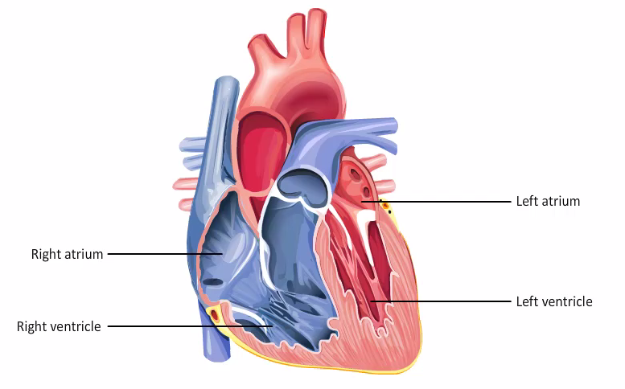For an elder with hypertension:

* + Make sure the elder takes their medicines on time
  + Test and record their blood pressure levels
  + Help the person make the advised changes to their diet
  + Ensure that the elder is involved in some form of exercise on most days of the week
  + If the elder under your care has symptoms such as chest discomfort, dizziness, fatigue, nausea, anxiety, breathlessness, persistent cough, or sweating, they may be having a heart problem. Inform the elder’s family and doctor immediately

For an elder who has suffered a heart attack or undergone a surgery:

* + Be patient and sympathetic
  + Ensure that they take their medicines on time
  + Assist them with their routine activities and gradually, encourage them to become more independent
  + Help the person make recommended changes to their diet
  + After checking with the family and the doctor, encourage the elder to exercise regularly

If the elder has undergone a surgery:

* + Keep the wound completely clean
  + Watch the site for any signs of infection and pus discharge
  + Inform the family and the doctor if you notice any signs of infection

If the elder has a pacemaker implant:

* + Remind the elder’s family to take the phone numbers of the pacemaker technician and the elder’s cardiologist
  + Make sure the elder does not go near any magnetic fields
  + If the elder dies, ask the family to consider getting the pacemaker removed by a doctor before the final rights of the elder are performed

**Respiratory Issues in the Elder**

* Recognize the most common symptoms of respiratory diseases
* Give the elder vitamin supplements and food rich in Vitamin C to prevent a cold
* Keep the elder away from people who may infect them with a cold
* If you have a cold, wear a barrier mask and gloves when in contact of the elder
* Clean the contact surfaces if someone in the house has a cold
* Wash the elder’s dishes separately to prevent a cold
* If you know what allergies an elder has, keep them away from the source of the allergy
* If the elder displays an allergic reaction, give the elder an anti-allergy pill, as prescribed by the doctor
* Give decongestant pills, as prescribed by the doctor, to elders suffering from cold, allergy or sinusitis
* Give nasal spray or drops followed by steam inhalation to the elder for decongestion
* Get the elder with a sore throat to gargle
* Help an elder who has laryngitis to take steam inhalation and gargle
* Give steam inhalation and encourage deep breathing exercises for an elder with bronchitis
* Give an elder with pneumonia plenty of fluids, rest, and follow the medication schedule as per the doctors’ orders
* Prevent asthma by keeping the elder with known allergies away from exposure to the allergens
* Help an elder suffering from chronic asthma or other respiratory diseases with using an inhaler, spacer, or nebulizer, as advised by the doctor

**Helping the Elder & Family deal with Terminal Illness**

* Never bring up the topic of death yourself
* Let the elder’s family members deal with issues regarding death
* Consult the elder’s family on what to do if the elder wants to discuss their condition
* Help the elder reach the stage of acceptance
* Help the elder spend their last days with a positive outlook
* Help them celebrate their life and count their blessings
* Encourage them to do whatever brings them peace